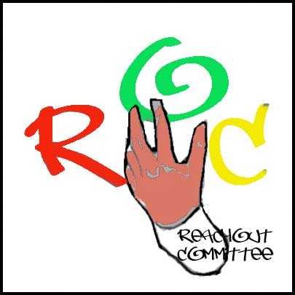

Head Office
Camilla Place
130 Dundas St. East, Suite 200
Mississauga Ontario L5A 3V8
Office tel. (289) 232.6407* (416) 571-9337 (24hr)
Reachout-committee@sympatico.ca
www.reachout.jimdo.com

Dear Parent/Guardian:

Your child has been invited to participate in a Youth Forum that is funded by the Ontario Trillium Foundation and coordinated by Reachout Committee Inc for this that is working with communities to reduce risk behaviours and promote positive youth development. The WAVE FOR CHANGE is collaboration among Reachout and the black youth of Peel.

The purpose of the Youth Forum is to give youth a voice regarding the issues black young people are facing their communities, and to provide information to adults making decisions that affect their lives. We believe that truly effective youth programs are marked by high levels of youth involvement, not just as program recipients, but as valuable resources who give program direction. When youth have a voice, a voice that's heard and acted on by adults, they have power to change their world for the better.

The first of the series of Youth Forum is being held in the Region of Peel and will focus on Education. Youth from across the Region of Peel and across the GTA will is participating. The Youth Forum will take place from 11-3 pm. During the first phase, the young people will present their ideas and concerns to a panel of decision makers who will listen to the youth presentations, and then provide a reaction to what have been said. Young people will work during the second phase in small groups to identify issues and generate ideas on how to prevent risky behaviour and promote well being. The Listener Panel will include representatives from the Various Ministries, government agencies and community agencies

We seek your permission so that your child can participate in the Youth Forum. Please sign the attached consent form, noting also whether you will allow your child to appear on the videotaped recording of the event. If you have any questions or concerns, please contact us at 289-232-6407.

Thank you for your support.

WAVE for CHANGE
Reachout Committee

Head Office
Camilla Place
130 Dundas St. East, Suite 200
Mississauga Ontario L5A 3V8
Office tel. (289) 232.6407* (416) 571-9337 (24hr)
Reachout-committee@sympatico.ca
www.reachout.jimdo.com

I give permission for my child ______________________________________ to participate in (name of child)

the WAVE for Change Youth Forum by Reachout Committee Inc. that will be held in Peel

Name ____________________________________________________

Signature ____________________________________________________

Date ____________________________________________________

I give permission for my child ______________________________________ to appear in the (name of child)

videotaped recording or Pictures for the WAVE for Change Youth Forum sponsored by the Reachout Committee Inc

Name ____________________________________________________

Signature ____________________________________________________

Date __________________________________________

